**Screenshot of OUTPUT OF TASK**

**Descriptive Analysis**

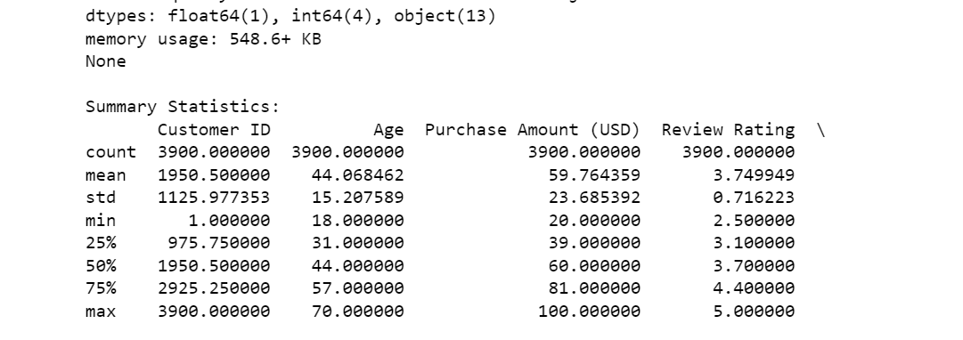

**Scatter Plot**

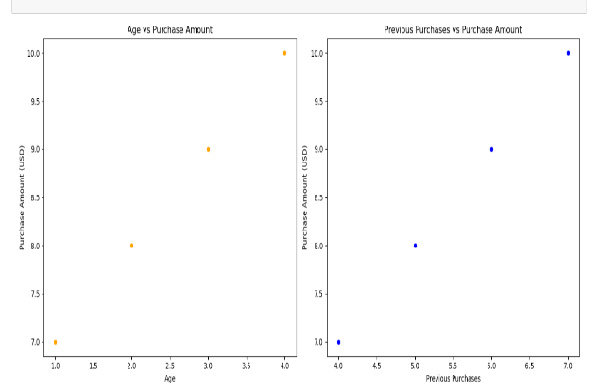

**HEAT MAP**

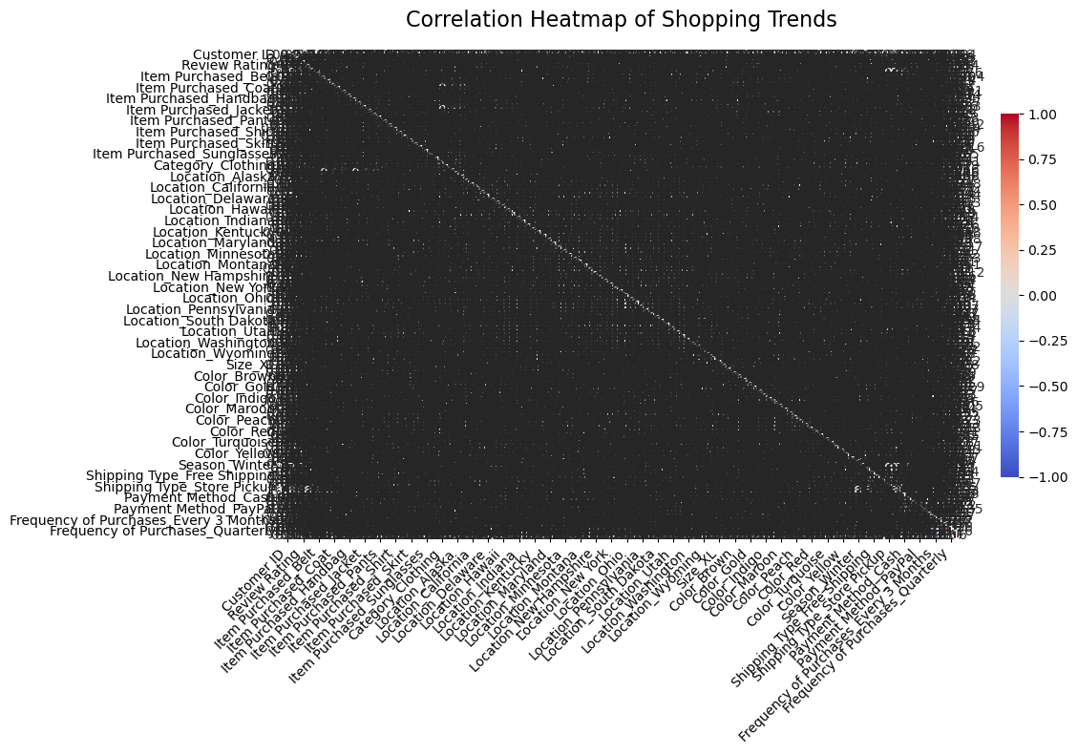

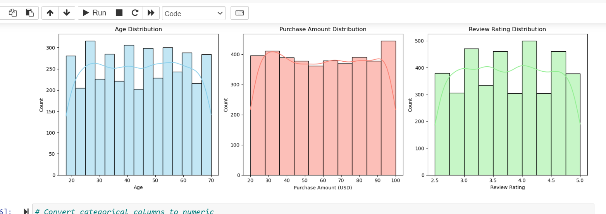**HISTOGRAM**

**BOXPLOT**

